Ideation Phase
Define the Problem Statements
Date | 12 October 2026
Team ID: | SWUID2026403326
Project Name | IMovies - Online Movie, Event & Entertainment Ticket Booking System
Maximum Marks | 2 Marks
Customer Problem Statement Template:
To define the core problems movie-goers, cinema managers, event organizers and administrators face when discovering and booking tickets online, and use those insights to guide the development of IMovies.
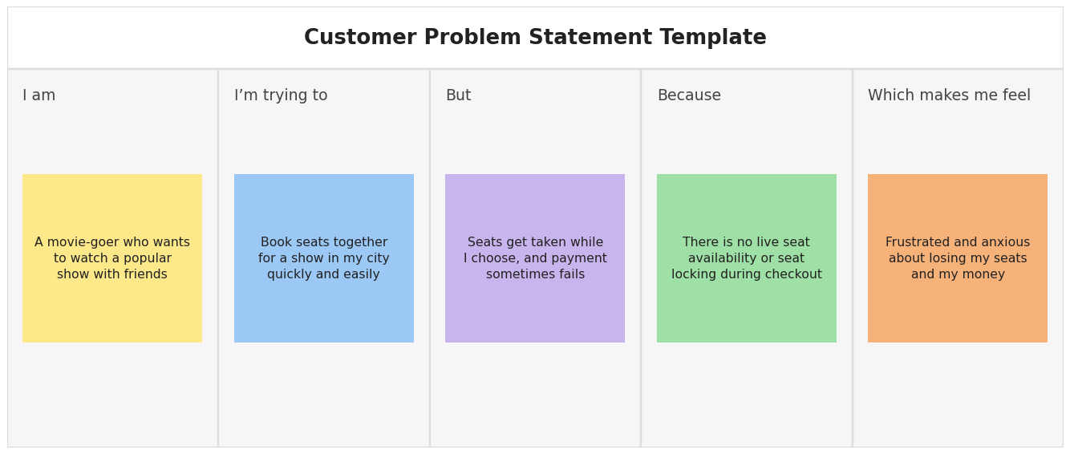
Reference: https://miro.com/templates/customer-problem-statement/
Problem Statement (PS) | I am (Customer) | I’m trying to | But | Because | Which makes me feel
PS-1 | a movie-goer planning a show with friends | book seats together for a popular show | the seats I choose get taken by someone else and payment sometimes fails | there is no live seat availability or seat locking during checkout | frustrated and anxious about losing my seats and money.
PS-2 | a frequent movie-goer in a busy city | find movies, cinemas and showtimes near me in one place | I have to check several apps and cinema sites | listings are scattered and search and filters are weak | annoyed and that I am wasting time.
PS-3 | a customer whose plans have changed | cancel my booking and get my money back | the cancellation rules and refund status are unclear | policies are hidden and refunds are slow and not tracked | worried and unsure whether I can trust the service.
PS-4 | a cinema manager running several screens | schedule shows and keep every screen well filled | I cannot see live occupancy and show timings sometimes clash | bookings and schedules are handled manually or in separate tools | stressed and unable to plan or price shows well.
PS-5 | an event organizer selling concert or workshop tickets | sell tickets by category without overselling | capacity and ticket types are hard to control and track | there is no tool that shows sales per category in real time | anxious and exposed to financial losses.
PS-6 | a platform administrator | monitor bookings, refunds, users and revenue | data is spread out and hard to audit | there is no central dashboard, analytics or audit trail | overwhelmed and slow to respond to problems.

